ULAS
ULAS is an RAF Volunteer Reserve Unit for undergraduate students
UNIVERSITY OF LONDON AIR SQUADRON
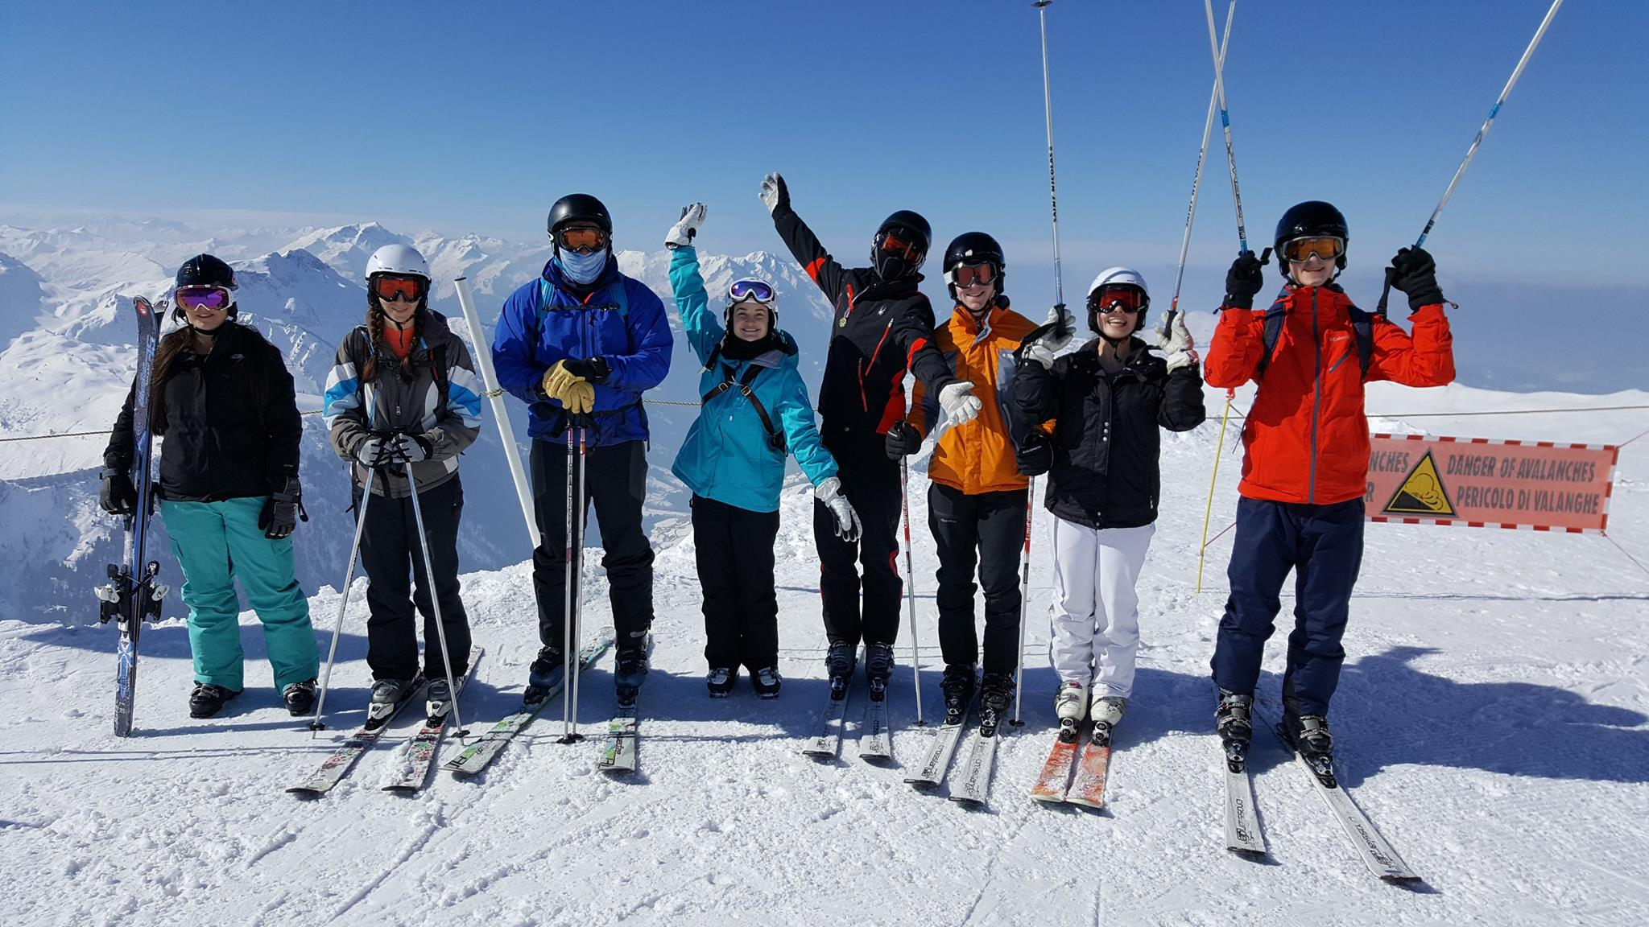
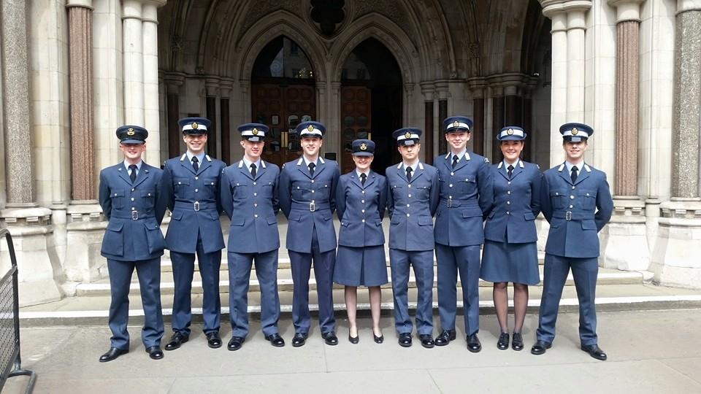
FLYING - SPORTS - LEADERSHIP - ADVENTUROUS TRAINING - EXPEDITIONS
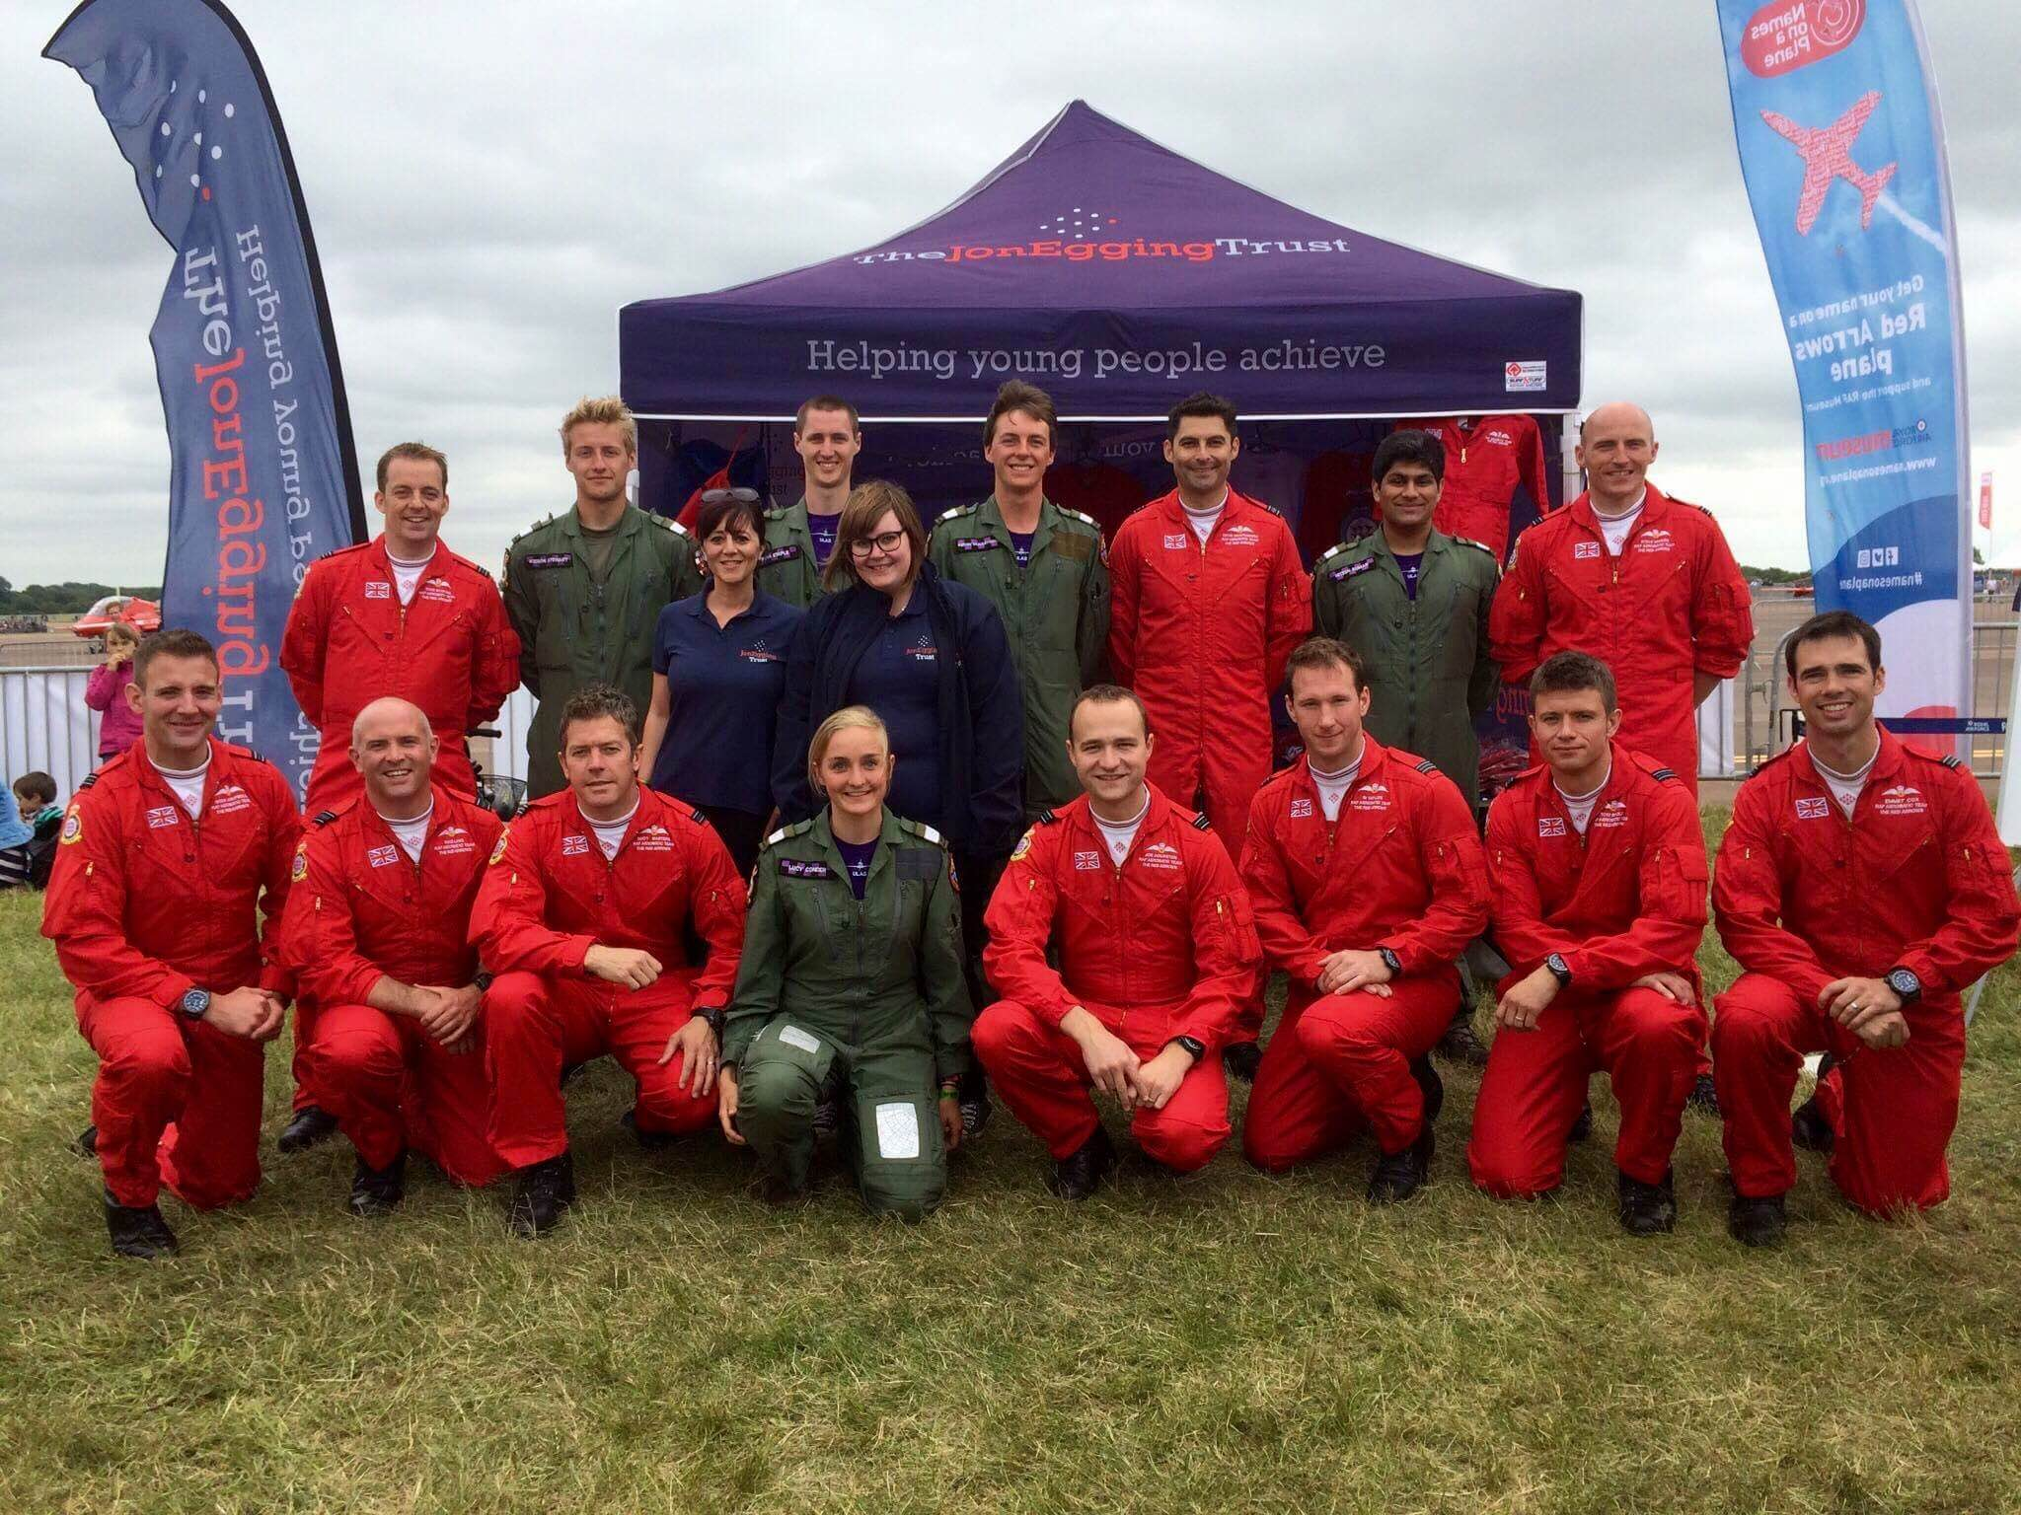
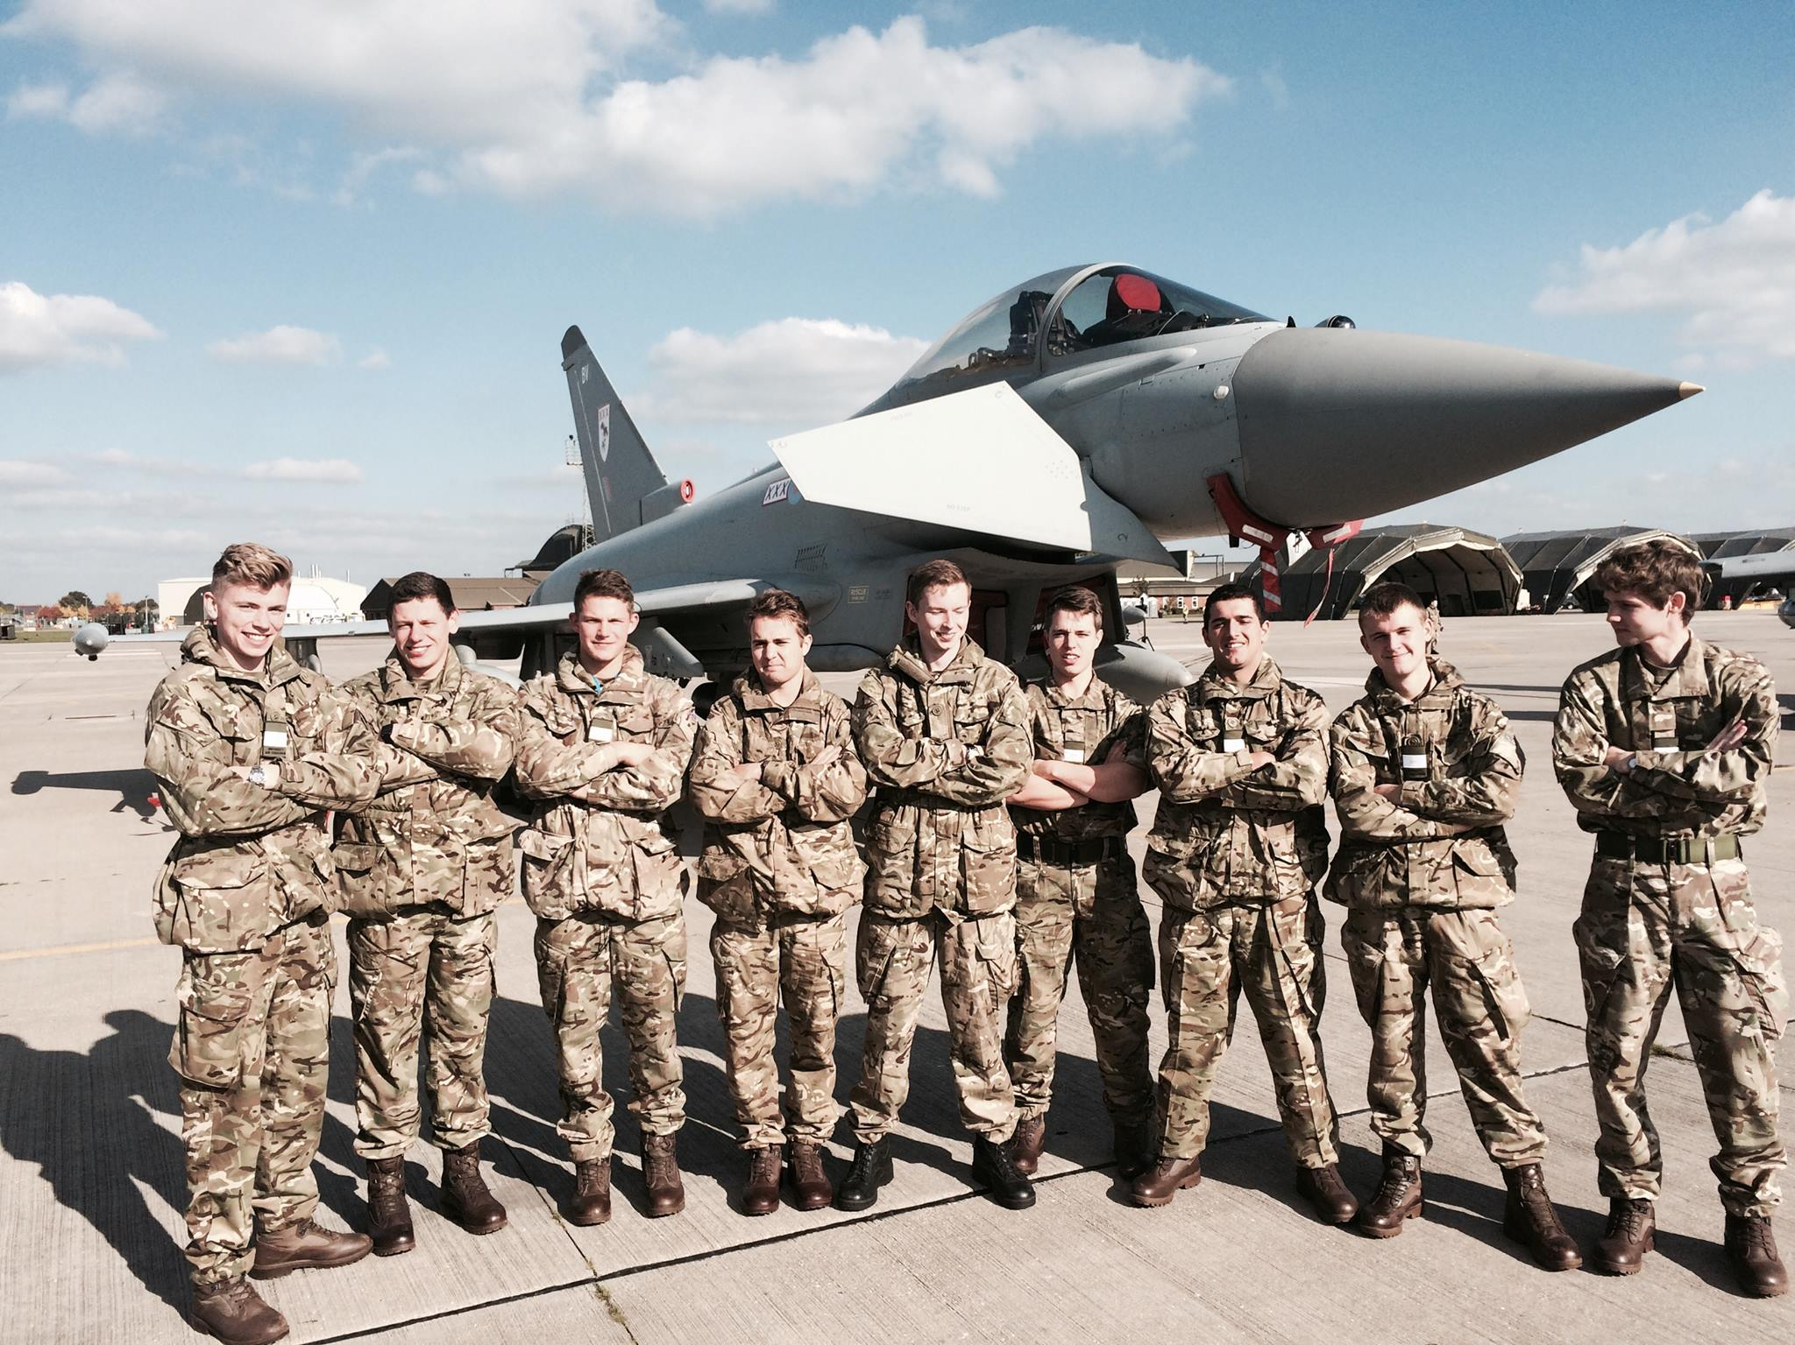
To learn more and apply to join, come along and meet us at one of the following Fresher’s Fairs or e-mail: 6FTS-ULAS-Adj@mod.uk

Royal Holloway 19/20 Sep 16 University of Hertfordshire 30 Sep 16
Brunel 20 Sep 16 University College London 1/2 Oct 16
Kings College London 23/24 Sep 16 Imperial College 4 Oct 16

Closing date for application: 1200 hrs on 05 Oct 16 by Email or post (please see below for adresses)

Key Dates: Interview Week 17-21 Oct 16
Fitness Test 24 Oct 16
Admin Afternoons 9 or 10 Nov 16
Training Nights 10, 17 and 24 Nov, 01 and 08 Dec 2016
Induction Camps 12-16 Dec 2016 or 03-06 Jan 2017

WE PAY YOU a pro-rata daily rate of around £40, up to a maximum of 35 days pa. In addition, we will refund your travel costs to RAF Northolt (personal contribution and exclusions apply).

ELIGIBILITY In order to join a UAS you must fulfil the following criteria:

- Full time student at an affiliated university, not foundation year students
- At least 3 terms left on your course.
- Physically fit
- British Citizen, British National for 5 years, Republic of Ireland Citizen
- British Citizens should normally have resided in the UK for the past 3 years
- Commonwealth Citizens should have resided in the UK for the past 5 years

There are medical conditions which will preclude eligibility and can be found at:

https://www.raf.mod.uk/recruitment/media/1652/medical-conditions-that-preclude-entry.pdf

If you have any queries or are interested in joining but cannot make it to a freshers’ fair please seek further information from us.

CONTACT INFORMATION
Mrs T Gray follow us on
University of London Air Squadron @londonuas
RAF Northolt University of London Air Squadron
West End Road
Ruislip
Middlesex
HA4 6NG

Email: 6FTS-ULAS-Adj@mod.uk
Phone: 0208 833 8250

