UNIVERSITY OF LONDON AIR SQUADRON – INTERVIEW PREPARATION

General Information

Recruitment interviews for the the University of London Air Squadron (ULAS) begin shortly after the start of the academic year. These are face-to-face interviews and the dress code is jacket and tie, or ladies’ equivalent.

You will be requested to bring the following documentation to the interview:

- Full 10 year British Passport
- British Driving Licence (if held)
- P45 (if held)
- Birth Certificate
- Proof of Residence at your term time address
- GCSE/A Level Certificates
- GP Name and Address
- National Health Service Number

The interview is expected to last around 45 minutes and is split into two parts. The format closely reflects the interview process for candidaites applying for Initial Officer Training at RAF Cranwell.

You are requested to arrive 10 minutes prior to your interview time slot.

-----------------------------------------------------------------------------------------------------------------------------------

Interview Process – Part 1

The first part of the interview focuses on you and your achievements. The interviewer will want to hear about activities, club memberships, sports, AT, positions of responsibility, employment, charity and travel you may have undertaken in your life so far. This is your opportunity to really ‘sell yourself’ to the interviewer.

Interview Process – Part 2

The second part of the interview focuses on your knowledge of the Royal Air Force and current affairs. It can be sub-divided into three sections.

- The student’s knowledge of:

- The University Air Squadron Organisation.
- The role of the Royal Air Force in today’s environment.
- ‘Headline’ defence matters, such as the UK’s membership of NATO and recent/current UK military operations.

- The student’s interest in a Royal Air Force career. Whilst there is no obligation to join the Service after leaving the UAS, you can make a more compelling case for joining the Squadron if you have researched one or more of the career opportunities that are available for an RAF Officer.

- General awareness of current affairs. To prepare for this element of the interview, you should research three UK-centric events and three international events that have featured in recent news and media and be prepared to discuss your views on the circumstances surrounding these events. Keep an eye on the news in the run up to your interview and read around your chosen topics.

-----------------------------------------------------------------------------------------------------------------------------------

Useful Resources

ULAS. The ULAS website is available at:

https://www.ulas.org.uk/

UAS. For more information on the University Air Squadron, visit:

https://www.raf.mod.uk/our-organisation/university-air-squadrons/

Here you’ll gain an understanding of what we offer, where the University of London Air Squadron is based and what type of aircraft we use to provide flying training.

RAF. To learn more about the Royal Air Force, visit:

https://www.raf.mod.uk/

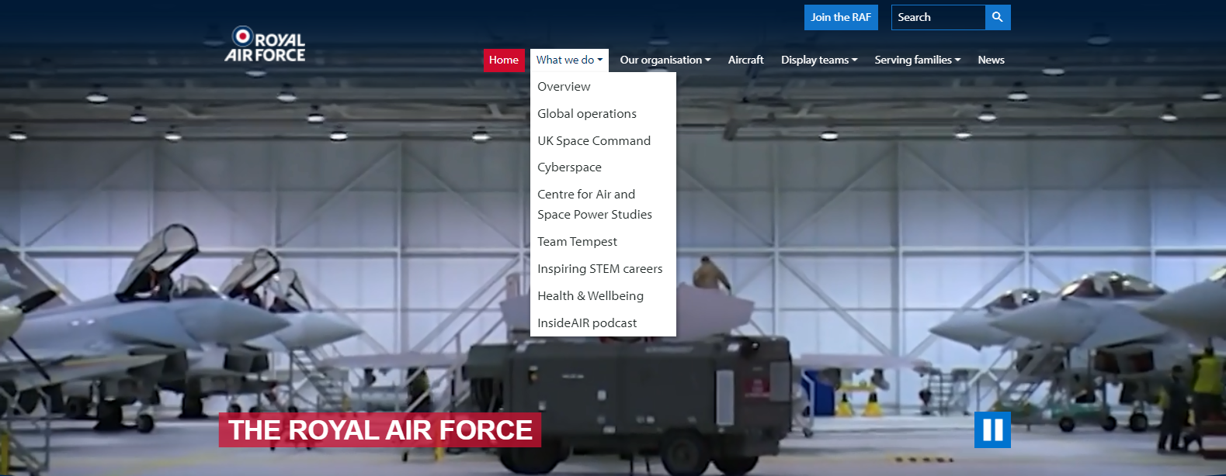

Here you’ll find a wealth of information about the Royal Air Force, it’s history and it’s involvement in current operations. Browse the website and try to find answers to the questions below:

- What is the definition of Air Power?
- What advantages does Air Power offer compared to that available from traditional land and naval forces?
- What are the distinct ‘Roles’ that are defined under Air Power?
- What RAF equipment (i.e. aircraft) delivers these distinct Air Power roles, and how?
- What military operations has the RAF been engaged with recently?

NATO. The UK’s membership of NATO determines much of our current defence policy and explains a lot of the historical change that has reshaped our foreign policy and armed forces over the last 25 years. Wikipedia has a good page on the history, purpose and changing mission of NATO. Here you can find out:

- When and why NATO formed; and how many nations founded NATO?
- When and why did NATO’s mission change after the break-up of the former Soviet Union?
- What effect has the expansion of NATO had on the relationship between the Russian Federation and Western Europe, and why?
- What is Article 5 of the NATO treaty?
- When and why was Article 5 of the NATO treaty invoked for the first and only time in history?

RAF Careers. We don’t expect all students to have a carefully considered plan to join the RAF. However, you can impress your interviewer if you have taken the time to find an RAF Officer role that may interest you in the future. If you have a determined aim to join the RAF… fantastic! We will help you to realise that ambition. For information on available roles, visit:

https://www.raf.mod.uk/recruitment/

Find career paths that may interest you and research the unique duties of each role, or roles. Have a think about the following:

- What are the unique personal and professional qualities expected from all RAF Officers?
- What is an Officer Commission? How does commissioned service differ from enlisted service?
- What is Initial Officer Training, where is it conducted and what is the course structure?
- After successful commissioning as an Officer, where might your further training take place and what are the landmark events that lead to final qualification?
- What would a first operational tour consist of in your chosen branch?
- What long-term career opportunities may be offered by the Royal Air Force?

